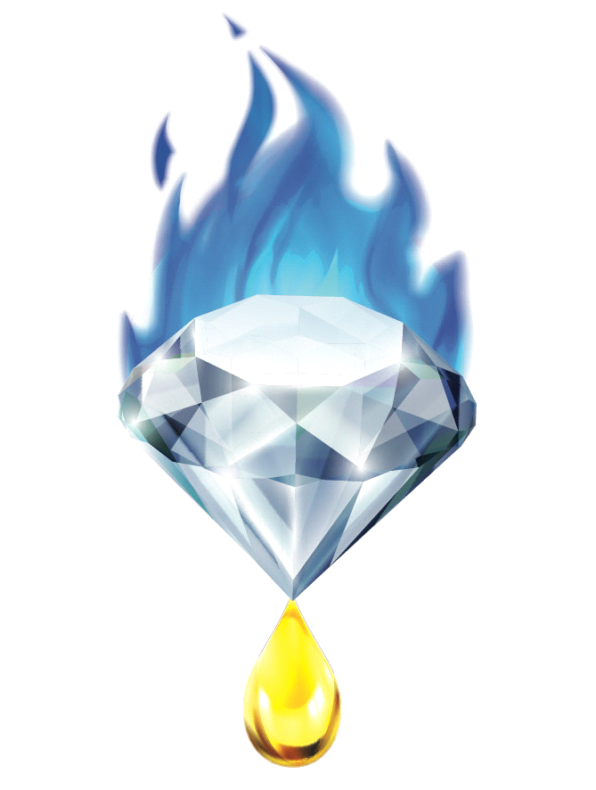 -Steam Distillation- -V1-
- Standard Operating Procedure -
Department - Process and Chemistry
Department Head - ____________________ Date ______
Provider - Gemstone Essential LLC
Purpose – To achieve a high quality fragrant essential oil of biomass sample for the purposes of compound qualification, product flavor/fragrance additive, and bioactive integration. Essential Oils are collected by creating conditions to quickly remove the Lighter-Than-Air components from a botanical sample, and removing the oil from atop its co-distilled hydrosol collection.
Document Control - Document Revision & Approval History
Revision | Pages | Prepared By | Reviewed By | Approved By | Date
#1 |  | Gemstone Essential | Gemstone Essential | Gemstone Essential

Definitions –
Decarboxylation - Removal of the Carboxylic acids from compounds in the oleoresin
Essential Oil - Lighter-than-air and fragrant fractions of extracted oleoresin
Extraction – Treatment of organic matter with an organic or non-organic solvent for the purpose of concentrating valuable Drug and Non-Drug type molecules
Extraction Vessel- (EV) Container in which extraction protocols are conducted. An appropriate vessel that can handle required solvent, temperature, and pressure variables.
Extract Liquor – Post- extraction oil containing ethanol
Filtration – The use of filters, sieves, or separation to remove solid and semi-solid contaminates from a liquid collection
Keck clip – Plastic/ stainless steel clamp that fits snugly to specific scientific glass joint sizes to ensure separation does not occur
Oleoresin - Extracted Oil-bearing products from the Cannabis plant lineage
Terpenes – Individual Fragrant molecules that make up an Essential Oil
Volatiles - Fraction of low molecular weight compounds that have a BP below 120ºc under vacuum.
Reaction - A process in which chemicals undergo a change of molecular structure
e.g. Decarboxylation of THC-Acid into THC
Equipment –
Boiling/ Liquid Trap Vessel (round bottom flask, jacketed vessel)
Heating equipment (heat mantle/ Steam generator, recirculating heater)
Material Vessel (Glass/ Stainless Steel biomass vessel)
Liquid Condenser (Glass/ Stainless)
Cold Heat Transfer Fluid Recirculator
Oil/water Separatory Funnel
Vapor Transfer Arm
Pipette
Essential Oil Storage Vessel (25-250mL)
Hydrosol Storage Vessel (1-5L)
Liquid transfer tubing

Procedure –
- Break up Biomass until a 1-2 cm particle size is achieved throughout
- Place a stainless steel mesh screen (10-25 lines per inch) at the bottom joint of the Material Vessel to ensure biomass is retained
- Load Material Vessel with desired biomass. Use only moderate packing methods: (too tight of packing will cause steam channeling and cause a detriment to overall quality and yield)
- Assemble Steam Distillation set up as shown below 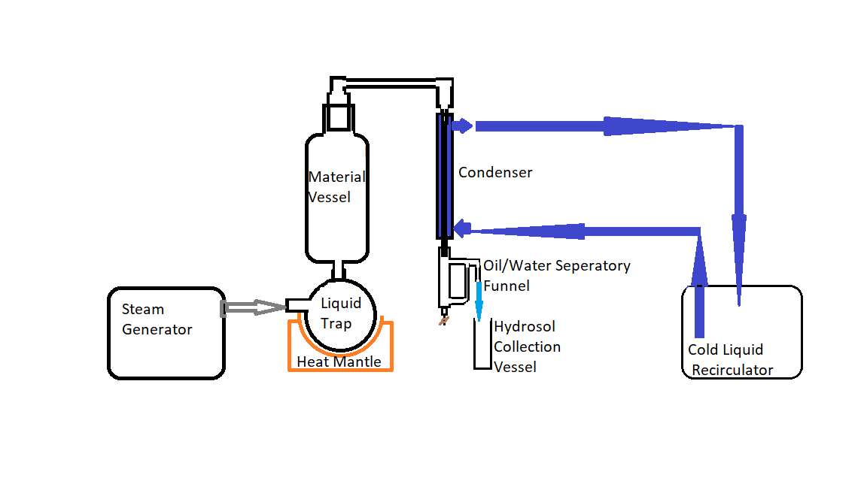
  - Fill Steam Generator with water
  - Attach water-out line of Cold Liquid Recirculator onto bottom hose barb of condenser
  - Attach water-in line of Cold Liquid Recirculator onto top hose barb of condenser
  - Attach Steam Generator steam hosing to Port 1 of Liquid Trap Vessel
  - Place Liquid Trap in Heat Mantle/ temp. appropriate vessel stand
  - Place Material Vessel on primary ground glass joint of Liquid Trap Vessel, secure with lab stand clamp and Keck Clip
  - Place large joint of Vapor Transfer Arm on top of Material Vessel joint
  - Place Condenser under small joint of Vapor Transfer Arm, Secure with Keck clip and lab stand clamp
  - Fill Oil/water Separatory funnel with Distilled water
  - Place Oil/Water Separatory funnel under bottom joint of Condenser. Secure with Keck clip and Lab stand clamp. Ensure stopcock valve is closed
  - Attach hose from hydrosol port of Oil/ Water Separatory Funnel and place in Hydrosol Collection Vessel
- Set Cold Liquid Recirculator to 2-5°c and begin recirculation. If no Cold Liquid Recirculator is available, use a bucket of ice water and an aquarium pump
- Begin Steam Distillation by initiating Steam Generator function
- Allow steam to travel from Steam Generator through setup and into condenser
- If vapor is seen to be exiting Oil/Water Separatory Funnel, or if Oil/ Water Separatory Funnel is warm or hot to the touch, stop operation and check Condenser/ Cold Liquid Recirculator is operating properly.
- If liquid is trapped at the bottom of the Material Vessel, and appears to be soaking/ refluxing over material, momentarily pause Steam Generator operation and allow liquid to drain.
- Collect Essential Oil by removing Oil/ Water Separatory Funnel and using a pipette to transfer Oil into suitable Essential Oil Collection Vessel; Draining via Stopcock will cause loss of yield due to transfer loss on glass walls.
- Place air-tight cap on Essential Oil Collection Vessel and place in a freezer to freeze any remaining water/hydrosol. Filter through small glass funnel with clean a cotton ball into a new, clean Essential Oil Collection Vessel
- FOR BEST RESULTS:
  - Load only Distilled water into Steam Generator
  - After 20 minutes of operation: Collect multiple fractions of essential oil. (Earlier fractions will be of higher quality)
    - Momentarily stop Steam Generator
    - Remove Oil/ Water Separatory Funnel
    - Use a pipette to drain off oil level which collects on top of the hydrosol collected within the Oil/ Water Separatory funnel
    - Re-connect Oil/Water Separatory Funnel, ensure secure connection with Lab stand Clamp and Keck Clip
    - Resume operation
  - Use fresh, high quality biomass

