 | Benchtop Winterization/ Lipid Removal V1 | 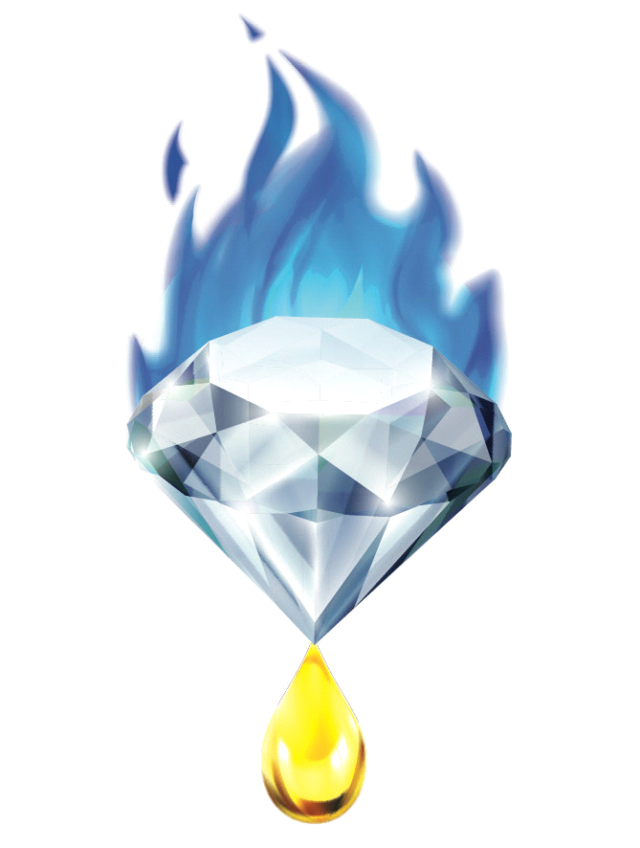
Revision Date: 9/31/2018 |  | Document #
- Standard Operating Procedure -
Department - Process and Chemistry
Department Head - ____________________ Date ______
Provider - Gemstone Essential LLC
Purpose - For the precipitation and separation of the naturally occurring lipids from a Cannabis or Hemp extraction. Removal of the lipids is necessary for multiple further refinement processes. Removed lipid fraction can be utilized in a variety of purposes and products.
Definitions -
Decarboxylation - Removal of the Carboxylic acids from compounds in the oleoresin
DV - Decarboxylation vessel
Essential Oil - Lighter-than-air and fragrant fractions of extracted oleoresin
Oleoresin - Extracted Oil-bearing products from the Cannabis plant lineage
Terpenes - (See Essential Oil)
Volatiles - Fraction of low molecular weight compounds that have a BP below 130ºc under vacuum.
Precipitation – Solidification and fall out of
Reaction - A process in which chemicals undergo a change of molecular structure

Equipment –
- Winterization Vessel (stainless steel/ glass beaker, solvent-proof plastic bucket
- Stainless Steel/ Silicone tools e.g. Stir tool, spatula,
- Filter Funnel e.g. Buchner, Fritted Disk, Bel Art, Stainless Steel
- Collection Vessel- Vacuum/ Solvent safe Glass, Metal, or Plastic bottle, filter flask, carboy
- Vacuum Pump – Diaphragm Chemical safe preferred
- Vacuum Cold Trap
- Appropriately sized vacuum tubing
- PPE – Safety goggles, Solvent proof gloves, Lab coat
- Filtration media
  - Filter Paper 25-.5µ, glass/ steel wool, propak, adsorbant/ physical media i.e Celite, Silica, Perlite
- Filter paper re-enforcement ring (if available)

Procedure –
- Record starting weight of cannabis oleoresin to be winterized.
- Prepare 1-2x volume of oleoresin in cleaned Ethanol or Acetone, place in appropriately sized glass or stainless steel vessel. Heat to 50°c
- Prepare 2-5x Volume of oleoresin in cleaned Ethanol or Acetone, allow solution to reach room temperature.
- Place oleoresin in a glass/ stainless steel vessel, heat until oleoresin reaches 50°c on a stirred hot plate.
- While solvent is being stirred, slowly pour oleoresin into solvent vessel, allow stirring/ agitation until solution completely dissolves and reaches full clarity i.e. the lack of any clouding/ flocculation.
- Begin stirring of 2nd volume of room temperature, cleaned solvent. Slowly pour Dissolved Solution into clean solvent. Botanical waxes and lipids should instantaneously flocculate and cloud up the solution.
- Allow solution to cool to room temperature or refrigerate to fairly colder.
- (If applicable) Prepare solution of filter media in winterization solvent at a 1:5 v/w ratio

- Prepare filter apparatus by connecting equipment via vacuum tubing in the following manner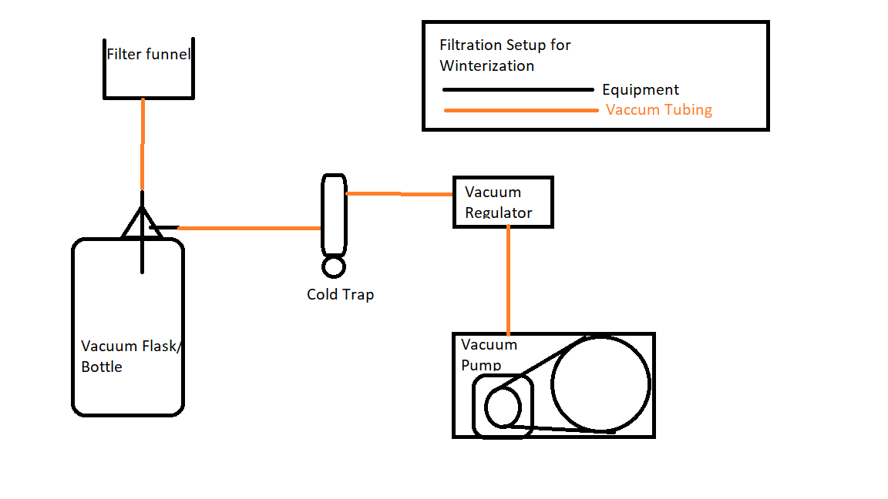

- Prepare Filtration funnel initially with a filter paper of 10-25 Micron.

- After assembly is completed, wet filter paper with 75mL of extraction solvent. Initiate vacuum momentarily to seal filter paper to filter funnel. (Note: some manual sealing may be needed to properly secure the filter paper if no filtration ring is used)

- After vacuum is initiated and filter paper secure, pour additional solution of filter media and solvent into filter, stop vacuum and allow to settle for .5 – 1 minutes.

- Once filter media bed is settled, place a small mesh or paper filter in the middle of the filter bed solution. You will pour filter solution onto this to disrupt the flow and maintain a level filter media bed.

- Secure filter housing/ top ferrule and fittings (Pressurized filtration only)

- Apply vacuum set to 100torr / Apply pressure set to 15-50 PSI (pressurized filtration only)

- Pour/ Inject room temperature/ slightly chilled solution into filter funnel. Maintain a consistent flow as to not let the filter media bed dry.

- Once solution is filtered, place in appropriate sized storage vessel.

- Chill to at least -20°c and conduct filtration as previously described.

- (Optional but preferable) Chill solution to <-40° and conduct filtration as previously described.

- Collect all material deposited on filter, dispose of appropriately

- (Optional) Wash and dissolve collected material with warm ethanol, and repeat filtration as previously described to achieve full extraction efficiency.

- For the sake of a swift process, the -20° may be skipped, only if a colder filtration is possible.

- Remove filtered solution from cold environment and allow to warm to room temperature/ warm with a Heat exchanger.

- Refer to Bulk Solvent Evaporation SOP for continuing steps.

- Disassemble filtration devices for cleaning.

