 | Decarboxylation V1 | 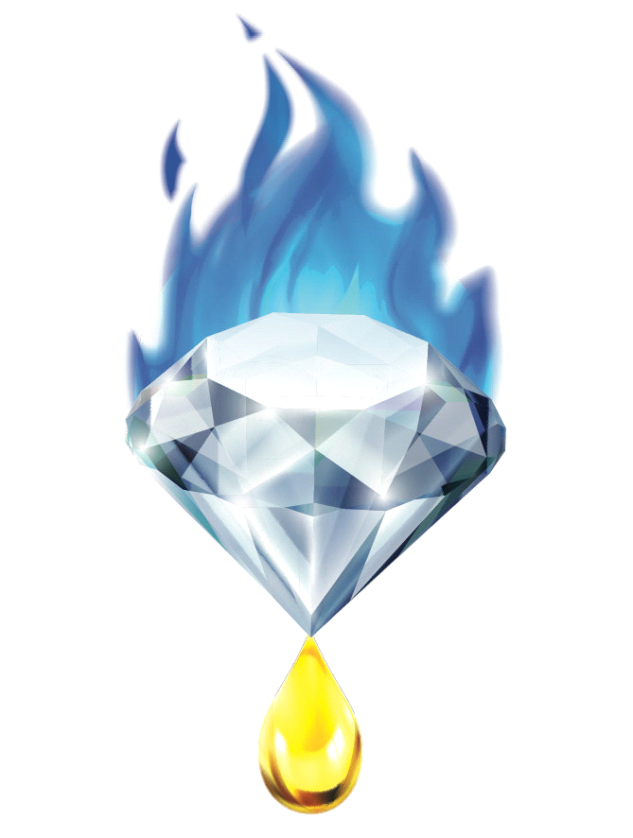
Revision Date: 9/31/2018 |  | Document #
- Standard Operating Procedure -
Department - Process and Chemistry
Department Head - ____________________ Date ______
Provider - Gemstone Essential LLC
“I have read and understand this SOP. I agree to fully adhere to its requirements”

Last | First | Employee ID | Signature | Date

Purpose - To establish guidelines for conducting the heat dependent decarboxylation and de-volatilization of the extracted oleoresin from the processing Cannabis and Hemp botanicals. Decarboxylation modifies the molecular structure of the constituents of the oil by removing the Carboxylic acid attached to Cannabinoid acids, modifying metabolic action. De-valorization refers to the process of removing both the fragrant and relatively low boiling (93º-130º Celsius) compounds from the oleoresin for the purposes of terpene/ essential oil capture and preparation for further processing and refinement.
Definitions -
Decarboxylation - Removal of the Carboxylic acids from compounds in the oleoresin
DV - Decarboxylation vessel
Essential Oil - Lighter-than-air and fragrant fractions of extracted oleoresin
Oleoresin - Extracted Oil-bearing products from the Cannabis plant lineage
Terpenes - (See Essential Oil)
Volatiles - Fraction of low molecular weight compounds that have a BP below 120ºc under vacuum.
Reaction - A process in which chemicals undergo a change of molecular structure
e.g. Decarboxylation of THC-Acid into THC
Equipment -
Traditional Method
Magnetic Stir Hot Plate & Stir Bar/ Beaker Mantle
Glass Beaker/ Stainless Steel Bain Marie (Recommended)
Thermometer
Stainless Steel or Glass stir rod
Terpene Collection Method
1 Liter Glass Round Bottom Flask, 24/40 joint
1 Liter Heating Mantle and Power Controller
24/40 Glass Male-Male distillation head/ 65 Degree Bend
24/40 Glass Bump Trap
24/40 Jacketed Allihn Condenser
90 Degree Glass Vacuum adapter
Water Recirculator/ Laboratory Chiller
Vacuum Pump/ Vacuum Hosing (optional)
Immersion Cold trap and insulated container (optional)
Dry ice/ Denatured Alcohol
Procedure -
Traditional Method
- Select DV with a maximum capacity of at least twice the volume of oleoresin used, add magnetic Stir Bar, record Tare weight of DV.
- A stainless-steel vessel (Bain Marie) is recommended due to its durability and higher heat transfer coefficient, however a glass beaker will also work well.
- Fill up to one-half of the total volume of the DV with extracted oleoresin. Record Oleoresin weight with DV Tare weight subtracted.
- Using a Controllable Heat Source (Hot Plate, Induction Cooktop), select your appropriate temperature based on time allotted.
- Decarboxylation Times and Temperatures (Approx., While data supports these times, original composition of Oil can change time required. Continue Operation until production of small semi-stable co2 bubbles ceases).
- 7 Minutes @ 145C
- 27 Minutes @ 122C
- 60 Minutes @ 106C
- Temperatures and times for decarboxylation are reliant upon a thin film of reactant, thick solutions allow for such less efficient heat distribution and gas exchange, so thicker solutions will need more time to decarboxylate fully.
- Set Stir function (Magnetic or Overhead Stirrer) at 240-1500 RPM to allow proper gas exchange. Lack of stirred agitation will result in boil over.
- If a layer of tiny bubbles grows on top of the decarboxylation, use a stainless steel or glass stir rod to break up the layer.
- Allow decarboxylation to continue until production of small semi-stable co2 bubbles ceases.

Terpene Collection Method
- Note: While terpenes are technically Generally Regarded as Safe (GRAS) by the US FDA, terpenes and other fragrant botanical chemicals can be significantly corrosive to certain types of Plastics and Rubbers. Select equipment and storage containers accordingly.
- Note: For optimal results, use freshly- extracted Oleoresin, prior to any secondary processing (Lipid/pigment removal, Aqueous-Separation)
- Note: If Vacuum protocol is utilized, ensure all Glass Joints are properly greased with an appropriate High Vacuum Grease. See Scientific Glass Joint Greasing SOP
- Record tare weight of Round Bottom Boiling Flask, record starting weight of extracted Oleoresin
- Assemble Glassware and equipment in the following manner
- Place Round Bottom Flask with loaded Oleoresin in Mantle, secure with temperature appropriate clamp. Add appropriately sized and shaped stir bar to the Round Bottom Boiling Flask.
- (if applicable) Place thermocouple/ thermometer adapter or thermowell in Round Bottom Boiling Flask. Connect to Mantle Temperature
- Place Fractional Distillation column on top of the Round Bottom Boiling Flask, secure into ground glass joint. Secure with temperature appropriate clamp and Keck Clip
- Place Bump Trap and/or Still Head on top of the Fractional Distillation Column. Secure into ground glass joint. Secure with temperature appropriate Keck Clip
- (if applicable) Connect thermometer/ thermocouple adapter to top of Still Head.
- Connect Condenser to Still Head takeoff. Secure with Keck clip and Clamp
- Place Angled Glass Adapter/ Vacuum Takeoff on far end of Condenser, secure in ground glass joint. Secure with Keck clip.
- Cold Trap. Ensure Cold Trap is Clean and sealed. Immerse/ expose Cold Trap to Electronic Cold Trap Bath, or Dry Ice. Slowly add ethanol or acetone to dry ice to maximize cooling efficiency. Accommodate for fume production
- Place Oil Water/ Separator below Angled Glass Adapter, Secure with Clamp and Keck clip.
- Connect recirculating coolant pump to lower jacket port (Hose Barb, GL Ace Thread) with flexible but sturdy tubing. Connect additional tubing to the upper jacket port (Hose barb/ GL/ ACE Thread), secure hosing to return to Coolant Reservoir
- Ensure Low temperature coolant is achieved, at least 10ºc constant coolant temperature is achieved. Lower temperature (5ºc to -30ºc)
preferred (if sub-0ºc coolant is utilized, ensure condenser has adequate volume of the vapor path, as to compensate for any freezing water
e.g. Use an Allighn or Dimroth Condenser, not a Graham.
- Initiate Recirculating Coolant Pump.

- If using Vacuum, initiate vacuum to system by turning on Vacuum Pump. If -50ºc or lower Cold Trap cooling is possible, full vacuum (2-20mmhg) is suitable. If these low depths of temperatures cannot be reached, regulate Vacuum at 200-350 mmhg, as to ensure full retention of fragrant compounds.
- Initiate heating of the Mantle until Oleoresin temperature reaches 75ºc, then initiate magnetic stirrer to 100-250rpm.
- Raise mantle temperature to 100ºc. Wait 15 minutes or until total oleoresin is liquid and flowing with the stir bar.
- Note: If using Vacuum, starting with vacuum pulled on the system, a ramp from 50-75-100ºc is suitable, and will help mitigate any foaming or bumping up the fractional distillation column.
- Once oleoresin is liquid and flowing with stir bar, raise Stirrer RPM slowly until maximum RPM is achieved. Fast Stir bar revolutions are important as a vortex is needed to break up the semi-stable co2 bubbles that form as a foam on top of the oleoresin. This is especially necessary in non-vacuum operations.
- Raise Mantle temperature to 125ºc after 20 minutes to allow for a gentler distillation of the lower molecular weight volatiles, preventing degradation of the Essential Oil
- Continue decarboxylation until cessation of small semi-stable co2 bubble production. This marks the end of the Decarboxylation.
- Once Decarboxylation is finished, turn off heat to the mantle, and allow oleoresin temperature to lower to below 70ºc.
- If vacuum is used, turn Vacuum pump off and open system to atmosphere.
- Disassemble system, clean off any used Joint Grease, and clean each piece of glassware except the Oil-Water Separator.
- Remove Hydrosol from Oil-Water Separator and collect in a sealable container.
- If a Cold Trap was utilized, remove Cold trap from coolant bath, wipe dry with a towel or cloth.
- Remove contents of cold trap and add it to Oil-Water Separator. Rinse Cold Trap with distilled water or hydrosol and add that to the Oil-Water Separator as well.
- Drain off Hydrosol, collect into hydrosol container.
- Drain off Essential Oil into suitable container. Place in freezer for 24 hours to freeze any lasting H2O in the Oil. Pour Essential oil into secondary suitable container.
F.A.Q.
- There are different types of bubbles being produced by my decarb operation, how can I tell that the operation is working?
A. Solvents, low-molecular weight terpenes, and other volatiles can cause bubbling, but these bubbles are very unstable, and will not last long on the surface of the reaction i.e. they will “pop” more violently than the subtle collapse of the co2 bubbles. The Co2 molecules produced from the reaction will group together into much smaller bubbles, and if proper agitation is not achieved, these bubbles are stable enough to fill the volume of the DV and spill over the edges.

